**Pom.xml**

<project xmlns="http://maven.apache.org/POM/4.0.0" xmlns:xsi="http://www.w3.org/2001/XMLSchema-instance" xsi:schemaLocation="http://maven.apache.org/POM/4.0.0 https://maven.apache.org/xsd/maven-4.0.0.xsd">

<modelVersion>4.0.0</modelVersion>

<groupId>com.cdac</groupId>

<artifactId>First-Hibernate2</artifactId>

<version>0.0.1-SNAPSHOT</version>

<name>First-Hibernate</name>

<properties>

<mysql.connector.version>8.0.13</mysql.connector.version>

<hibernate.version>4.3.0.Final</hibernate.version>

</properties>

<dependencies>

<!-- https://mvnrepository.com/artifact/org.hibernate/hibernate-core -->

<dependency>

<groupId>org.hibernate</groupId>

<artifactId>hibernate-core</artifactId>

<version>5.6.9.Final</version>

</dependency>

<!-- https://mvnrepository.com/artifact/mysql/mysql-connector-java -->

<dependency>

<groupId>mysql</groupId>

<artifactId>mysql-connector-java</artifactId>

<version>${mysql.connector.version}</version>

</dependency>

<dependency>

<groupId>org.hibernate</groupId>

<artifactId>hibernate-entitymanager</artifactId>

<version>${hibernate.version}</version>

</dependency>

<dependency>

<groupId>org.hibernate</groupId>

<artifactId>hibernate-ehcache</artifactId>

<version>${hibernate.version}</version>

</dependency>

</dependencies>

</project>

**Persistence.xml**

<persistence xmlns="http://xmlns.jcp.org/xml/ns/persistence"

xmlns:xsi="http://www.w3.org/2001/XMLSchema-instance" version="2.2"

xsi:schemaLocation="http://xmlns.jcp.org/xml/ns/persistence http://xmlns.jcp.org/xml/ns/persistence/persistence_2_2.xsd">

<persistence-unit name="persistense.cfg.xml">

<!-- Specifying which ORM we will be using -->

<provider>org.hibernate.jpa.HibernatePersistenceProvider</provider>

<properties>

<!-- Database settings -->

<property name="javax.persistence.jdbc.driver"

value="com.mysql.cj.jdbc.Driver" />

<property name="javax.persistence.jdbc.url"

value="jdbc:mysql://localhost:3306/pune?useSSL=false" />

<property name="javax.persistence.jdbc.user" value="root" />

<property name="javax.persistence.jdbc.password"

value="cdac" />

<!-- Additional settings -->

<property name="hibernate.hbm2ddl.auto" value="update" />

<!-- Auto creation of tables -->

<property name="hibernate.show_sql" value="true" />

<!-- Log generated SQL -->

</properties>

</persistence-unit>

</persistence>

**Actor.java**

package com.cdac.model;

import javax.persistence.Column;

import javax.persistence.Entity;

import javax.persistence.Id;

import javax.persistence.Table;

@Entity

@Table(name="Table_actor")

public class Actor {

@Id

@Column(name="Actor_Id")

private int id;

@Column(name="Actor_name")

private String name;

@Column(name="Actor_age")

private int age;

@Column(name="Actor_fees")

private double fees;

@Column(name="Actor_indusrty")

private String industry;

public int getId() {

return id;

}

public void setId(int id) {

this.id = id;

}

public String getName() {

return name;

}

public void setName(String name) {

this.name = name;

}

public int getAge() {

return age;

}

public void setAge(int age) {

this.age = age;

}

public double getFees() {

return fees;

}

public void setFees(double fees) {

this.fees = fees;

}

public String getIndustry() {

return industry;

}

public void setIndustry(String industry) {

this.industry = industry;

}

}

**insertActor.java**

package com.cdac;

import javax.persistence.EntityManager;

import javax.persistence.EntityManagerFactory;

import javax.persistence.EntityTransaction;

import javax.persistence.Persistence;

import com.cdac.model.Actor;

public class insertActor {

public static void main(String[] args) {

//create connection

EntityManagerFactory emf = Persistence.createEntityManagerFactory("persistense.cfg.xml");

EntityManager em = emf.createEntityManager();

EntityTransaction tx = em.getTransaction();

tx.begin();

// set values

Actor actor1 = new Actor();

actor1.setId(15);

actor1.setName("Vijay Setupati");

actor1.setAge(48);

actor1.setFees(200000);

actor1.setIndustry("Tollywood");

Actor actor2 = new Actor();

actor2.setId(17);

actor2.setName("Yash");

actor2.setAge(36);

actor2.setFees(100000);

actor2.setIndustry("Kollywood");

Actor actor3 = new Actor();

actor3.setId(14);

actor3.setName("Robert Downey Jr");

actor3.setAge(58);

actor3.setFees(1500000);

actor3.setIndustry("Hollywood");

// persist will add data to database

em.persist(actor1);

em.persist(actor2);

em.persist(actor3);

// close the connection

tx.commit();

emf.close();

System.out.println("Done...");

}

}

**Project structure**

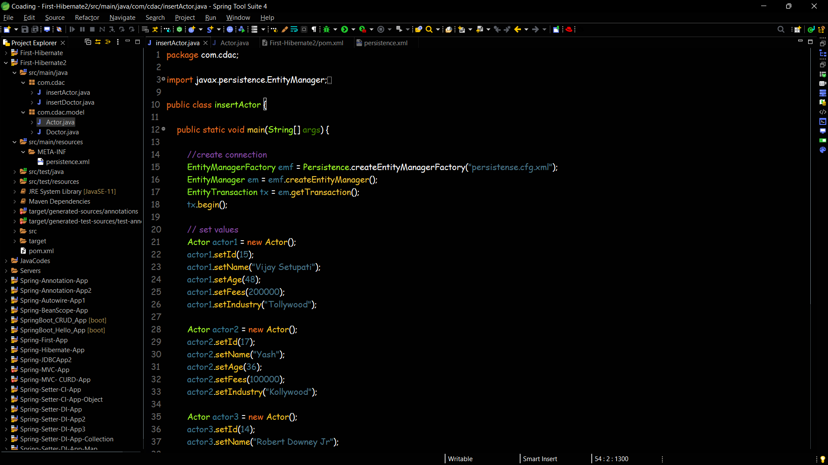

**Database table Data**

